Interior and Exterior Angles

lesson

7-1

Practice and Problem Solving: A/B

Find the measure of each angle.

1. 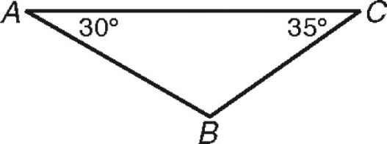 2. 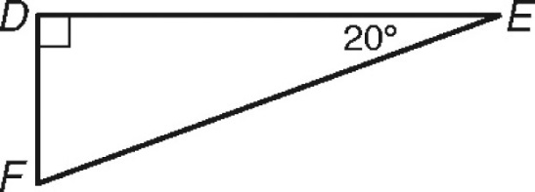

mB  ______ mF  ______

3. 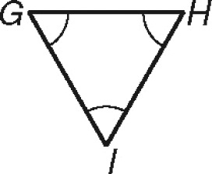 4. 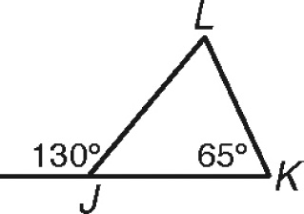

mG  ______ mL  ______

5. 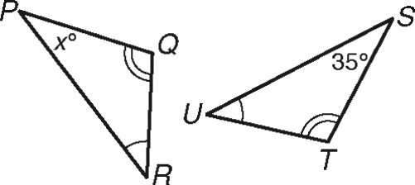 6. 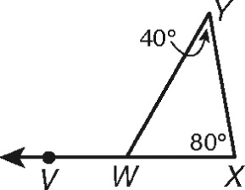

mP  ______ mVWY  ______

Use your knowledge of angle relationships to answer questions 7–12.

7. The sum of the angle measures of a quadrilateral is ______.

8. The acute angles of a ____________ triangle are complementary.

9. The measure of an ____________ angle of a triangle is equal to the sum

of the measures of its remote interior angles.

10. The angle measures of a triangle are a, 3a, and 5a. Tell the measure of each angle. ______, ______, ______

11. You know that one of the exterior angles of an isosceles triangle is 140. The angle measures of the triangle could be ______-______-______ or ______-______-______.

Isosceles and Equilateral Triangles

lesson

7-2

Practice and Problem Solving: A/B

For Problems 1–6, find each value.

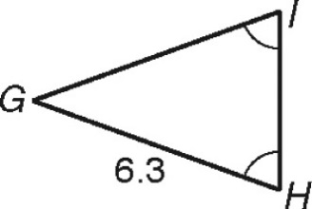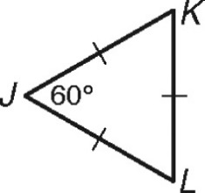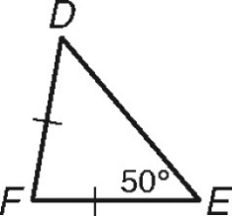 1. 2. 3.

mD  ______° GI  ______ mL  ______°

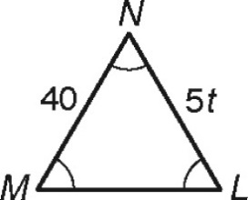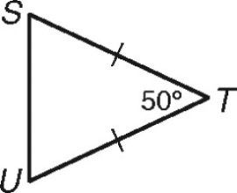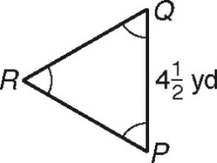 4. 5. 6.

RQ  ______ mU  ______° t  ______

Use principles of isosceles and equilateral triangles to answer Problems 7–9.

7. Point M lies on side JL of triangle JKL.  bisects  and forms   
equilateral triangle KLM. What is the measure of J? ________________°  
Make a sketch and explain your answer.

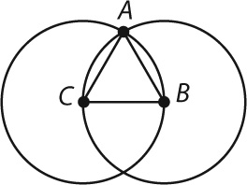 8. Circle B and circle C are congruent. Point A is an   
intersection of the two circles. Write a paragraph   
proof to show that $∆ABC$ is equilateral.

9. The Washington Monument is an obelisk,a tall, thin, four-sided monument that tapers to a pyramidal top. Each face of the pyramidal top of the Washington Monument is an isosceles triangle. The height of each triangle is 55.5 feet, and the base of each triangle measures 34.4 feet. Find the length, to the nearest tenth of a foot, of one of the two congruent legs of the triangle. ___________________________

Triangle Inequalities

lesson

7-3

Practice and Problem Solving: A/B

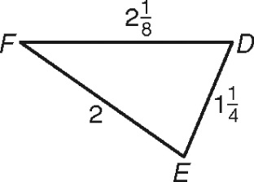For Problems 1–3, name the angles or sides.

1. Write the angles of $∆DEF$ in order from smallest to largest.  
 _________  _________  _________

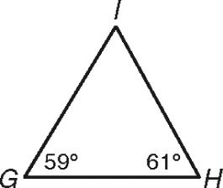 2. Write the sides of $∆GHI$ in order from shortest to longest.  
 _________ _________ _________

3. The sides of triangle XYZ are given in order below from longest to shortest. Name the angles from largest to smallest.

  

 _________  _________  _________

Use your knowledge of triangle inequalities to solve Problems 4–7.

4. Can three segments with lengths 8, 15, and 6 make a triangle? Explain

your answer.

5. For an isosceles triangle with congruent sides of length s, what is the range of lengths for the base, b? What is the range of angle measures, A, for the angle opposite the base? Write the inequalities and explain

your answers.

6. Aaron, Brandon, and Clara sit in class so that they are at the vertices of a triangle. It is 15 feet from Aaron to Brandon, and it is 8 feet from Brandon to Clara. Give the range of possible distances, d, from Aaron

to Clara.

7. Renaldo plans to leave from Atlanta and fly into London (4281 miles). On the return, he will fly back from London to New York City (3470 miles) to visit his aunt. Then Renaldo heads back to Atlanta. Atlanta, New York City, and London do not lie on the same line. Find the range

of the total distance Renaldo could travel on his trip.

MODULE 7 Properties of Triangles

LESSON 7-1

Practice and Problem Solving: A/B

1. 115

2. 70

3. 60

4. 65

5. 35

6. 120

7. 360

8. right

9. exterior

10. 20, 60, 100

11. 40, 40, 100 or 40, 70, 70

LESSON 7-2

Practice and Problem Solving: A/B

1. 50

2. 6.3

3. 60

4. 4  yd

5. 65

6. 8

7. 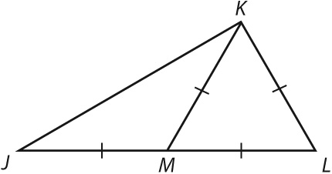

30.   and are congruent because they are the sides of an equilateral triangle. is also congruent to those three sides because *M* is the midpoint of  Angle *KML* is 60 because it is in an equilateral triangle. Angles *J* and *MKJ* have the same measure because they are opposite congruent sides in an isosceles triangle. Their sum is 60, so each one is 30.

8. It is given that circles *B* and *C* are congruent. is a radius of circle *B*,  is a radius of circle *C*, and  is a radius of both circles. All three segments are congruent because the radii of congruent circles are congruent. Therefore  is equilateral by definition because all three of its sides are congruent.

9. 58.1 ft

LESSON 7-3

Practice and Problem Solving: A/B

1. F; D; E

2.   

3. Y; X; Z

4. The three segments cannot make a triangle because 8  6  15; the two shorter sides together do not reach from one end of the longer side to the other.

5. 0  b  2s; 0  A  180  
If the congruent sides are very close together, the base length is close to 0, and the measure of the angle opposite the base is close to 0. If the congruent sides are very spread out, the base is close to 2s (the combined length of the congruent sides), and the angle is close to 180.

6. between 7 and 23 feet

7. Renaldo could travel between 8562 miles and 15,502 miles.